40 YEARS OF THE RIVERSIDE WALKWAY
COMPETITION - Help us find our trees
Please help us to locate around 60 native species of trees and hedges which were planted to mark the new Millennium and which were marked with a post and nameplate such as the one in the photograph.  Please record the ///what3words location for each tree below on this sheet.  A word of warning – we do not know how many of the trees or marker posts are still in place, but your help will be invaluable in helping to map them.  There will be a tree themed prize for the winning entrant. | 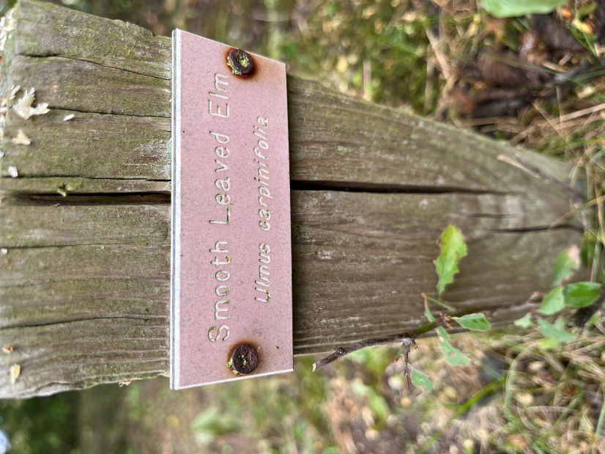

Common Name | Species | Type* | What 3 Words Location
Downey Birch | Betula pubesens | T
Silver Birch | Betula Pendula | T
Small-leaved Lime | Tilda cordata | T
Box | Buxus sempervirens | H
Holly | Ilex aquifolium | T & H
Alder | Alnus glutinosa | T
Hornbeam | Carpinus betulus | T & H
Beech | Fagus sylvatica | T & H
Elm | Ulmus procera | H
Crab Apple | Malus sylvestris | T
Whitebeam | Sorbus aria | T
Wild Cherry | Prunus avium | T & H
Bird Cherry | Prunus padus | T
Common Oak | Quercus robur | T & H
Sessile Oak | Quercum petraea | T & H
Field Maple | Acer compestre | T & H
Wild Service Tree | Sorbus torminalis | T
Ash Tree | Fraxinus excelsior | T & H
Rowan | Sorbus aucuparia | T
Yew | Taxus baccata | T & H
Pine | Pinus sylvestria | T
Juniper | Juniperus communis | T & H
Wild Privet | Ligustrum vulgare | H
Honeysuckle | Lonicera pericyclamen | C
Blackthorn | Prunus spinosa | H
Purging Buckthorn | Rhamnus catharticus | H
Alder Buckthorn | Frangula alnus | H
Dogwood | Cornus sanguinea | H
Hazel | Corylus avellana | H
Wayfaring Tree | Viburnum lantana | H
Sea Buckthorn | Hippophae rhamnoides | H
Guelder Rose | Viburnum opulus | H
Hawthorne | Crataegus monogyna | T & H
Midland Hawthorne | Crataegus laevigata | T
Elder | Sambucas nigra | H
Gorse | Ulex europaeus | H
Blackberry | Rubus fruiticosa | C
Ivy | Hedera helix | C
Burnet Rose | Rosa spinosissima | C
Dog Rose | Rosa canina | C
Spindle Tree | Euonymus europaeus | T
Wild Clematis | Clematis vitalba | C
Field Rose | Rosa arvensis | C
Sweet Briar Rose | Rosa rubiginosa | C
Hop | Humulus lupulus | C
Butchers Broom | Ruscus aculeatus | H
Spurge Laurel | Daphne laureola | H
Mezereom | Daphne mezerium | H
Cherry Plum | Prunus cerasifera | H
Goat Willow | Salix caprea | T
White Willow | Salix alba | T
Crack Willow | Salix fragilis | T
Osier Willow | Salix viminalis | H
Pear | Pyrus communis | T
Aspen | Populus tremula | T
Black Poplar | Populus nigra | T
Cotoneaster | Intergerriumus | H
Cotoneaster | Cambrica | H
Downey Rose | Rosa tomentosa | C
Soft Leaved Rose | Rosa villosa | C
* Type Indicated by T- Tree, H-hedge/shrub, C – Climber

Submitted by ………………………………………………………………………………………………………………..Name
………………………………………………………………………………………………………………………….Email/Mobile
Please return this form by 31 October 2026 to the Clerk, Jo Haslope at 22 The Triangle, North Ferriby HU14 3AT or by email to clerk@northferribyparishcouncil.gov.uk

