STREET CLOSURES UNDER THE TOWN POLICE CLAUSES ACT 1847

For events such as Carnivals, street Parties, Christmas Activities Etc.

APPLICATION PROCEDURE AND REQUIREMENTS

In order to approve a street closure, under the Town Police Clauses Act 1847, the East Riding of Yorkshire Council has drawn up the following procedures.

- The East Riding of Yorkshire Council will require supporting signatures of at least 70% of the frontages affected by the closure.

- 56 days is the absolute minimum notice the Highways Authority need to assess the implications of the closure and complete the necessary statutory requirements. It is recommended that longer periods of notice are given to prevent any likely hood of clashes of interest with streets works, which in some cases are planned 6 months in advance.

- An unobstructed safety corridor of at least 3. 25 meters wide must be maintained at all times to provide access for emergency vehicles, including the provision to allow Fire Appliances the ability to get to within 50 metres of any structure, including fuel stores. Turning areas are needed in dead-end access routes longer than 20 metres.

- The applicant is required to submit evidence of prior consultation with the Local Parish / Town Council and other affected parties such as Bus companies, local businesses, the emergency services and owners / occupiers of all affected frontages, the response from these consultations will be considered by the highways Authority when deciding a road closure.

- The road closure must have the full support of the Police.

- Applicants are responsible for the provision and placing of all the necessary traffic barriers and warning signs to comply with the Traffic Signs Regulations and Traffic Signs Manual. (See enclosed diagram on page 6).

The requirement for prior consultation is intended both as a public relations exercise and as an aid in deciding any relevant conditions for the closure, in order to minimise disruption and inconvenience to road users.

Please Note

Public Liability Insurance will be required for a minimum level of £5 million. For higher risk activities, (Carnivals, fun fairs, Christmas Activities etc) the Council will require a level of £10 million plus. Applicants will be advised.

APPLICATION FOR CLOSURE OF ROAD / CAR PARK

Date of the event

Type of Event

Requirements
Roads to be closed:
1.
2.
3.
Between the junctions:
1.
2.
3.

Between the hours of:

In order to determine whether this application should be approved, The East Riding of Yorkshire Council Highways Authority, require the supporting signatures and addresses on the form below of at least 70% of the owners and occupiers of the premises of frontages likely to be affected by the closure.

If you consider the closure would create unreasonable hardship to you, you may put your objections in writing to the Head of Legal and Democratic Services, County Hall Beverley HU12 9BA.

I am in favour of the proposed street closure as detailed above.

Signature Address

1 am in favour of the street closure as detailed on page 1

Signature Address

I am in favour of the street closure as detailed on page 1

Signature Address

1 Name of Organisation

2 Name of Applicant

3 Position within Organisation

4 Address of Applicant

5 Contact Details

Home Telephone
Work Telephone
Mobile
E- Mail

6 Please confirm in writing and provide copies of FIRE
Letters sent, that the emergency services have POLICE
been advised prior to the event-taking place AMBULANCE
including how means of access to the event
area is to be maintained.

If the road to be closed is part of a bus route then the bus operators must be consulted (i.e. EYMS or 1st York)

The event organiser is responsible for the co-ordination of information required by this application

The event must be covered by public liability insurance to a minimum of 2 million pounds for any one incident or accident

On completion please return this form to the Highways Events Officer, East Riding of Yorkshire Council Anne Reed Road Beverley HU17 0LF at least 56 days before the event with details of the road closure, plan of the event layout, public liability insurance and any other supporting documents.

Signature of Applicant

Date

Print Name

On approval, sufficient A4 laminated Temporary Public Road Closure Notices (Legal Public Notices) will be sent to the applicants address, who will then be responsible for their erection at least 7days prior to the event on lampposts or other suitable structures around the proposed road closure and removed immediately after the event.

EXAMPLE OF SIGNAGE FOR A TEMPORARY ROAD CLOSURE AND DIVERSION

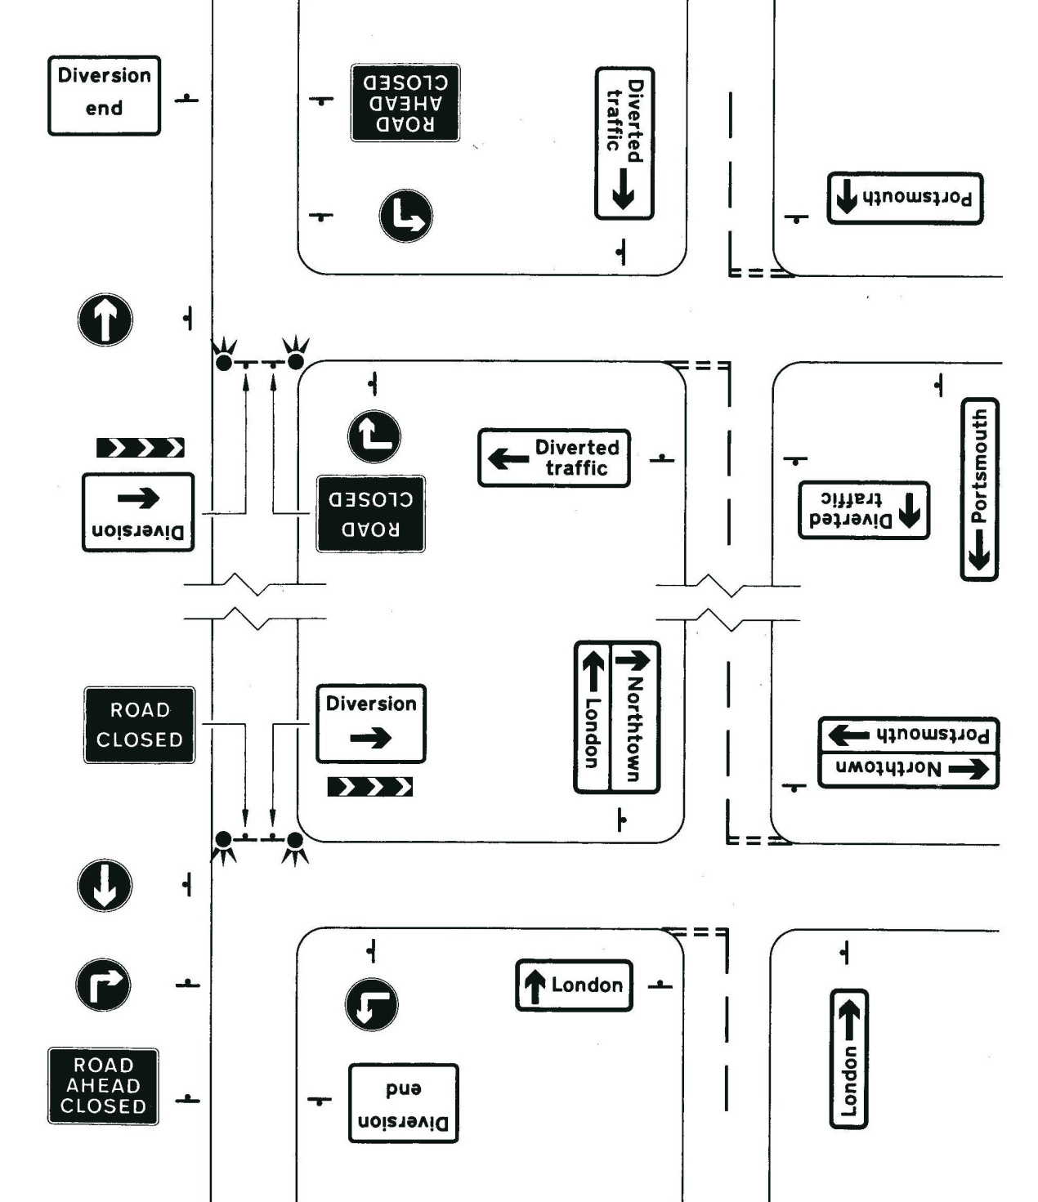

NOTES
Road closed and Road Ahead Closed signs
Reflective white lettering on a red background
Dimensions of signs 750 x 1050 mm, with appropriate sized lettering

Diversion Signs

Reflective black lettering and markings on a yellow background.
Dimensions of signs 750 x 1050 mm, with appropriate sized lettering.
Traffic barriers require retro reflective red and white barrier planks and posts

Contact Addresses
Humberside Police
Operations Planning
Melton Police Station
Wyke Way
Melton
HU4 3BQ

Humberside Fire and Rescue Service HQ
Operational Support
Summergroves Way
Hessle High Road
HULL
HU4 7BB

The Administrator
Yorkshire Ambulance Service
Beverley Ambulance Station
Driffield Road
Beverley
HU17 7LT

Planning Department
East Yorkshire Motor Services
252 Anlaby Road
HULL
HU3 2RS
01482 327142

Peter Edwards
First York Limited
7 James Street
York
Y01 3DW

